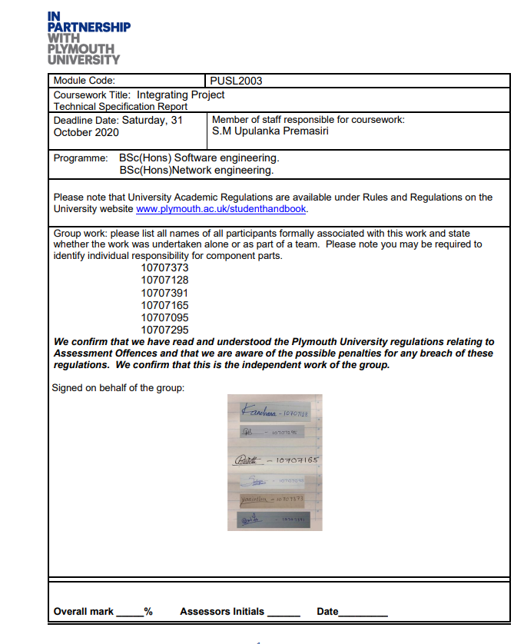

**Smart Parking System with Image Processing**

**(NSBM 19.1 ,54 group,** **Technical Specification Report)**

**Abstract:** Our study aims to improve parking facilities by introducing a new smart parking system that reduces empty parking space search time. Many recent parking technologies rely on aggression sensors to detect empty parking spaces and do not direct sponsors to a specific parking space.

Our system Also, user can view the duration of parking usage through this mobile app and calculate the charges. We can guarantee the security of the vehicles because we use image processing to capture the number plate of the drivers and we store them in a database to avoid theft and illegal car entry.

Sometime after reaching the parking area, we get to know that there is no space to park. It also a waste of time. To avoid this this situation, we can check the available spaces in the park through the application. In that kind of a situation, we can book our space early through the app and without any trouble or wasting time, person can park his vehicle without any delay. We issue a unique QR code to avoid conflict situations. As an example, sometimes we reserved our slot early but before we enter the parking area someone entered there and park his vehicle already. In such situation no point of arguing, because already we waste our time and, we are in trouble. Through this method we can ensure that, after getting this QR code no one can park his car in this reserved area except the reserved person.

Contents

**(1.1)** **Introduction** 4

**(1.2)** **Definition of the Problem** 4

**(1.3)** **Project Objectives** 5

**(1.4)** **Scope of Project** 5

**Summary** 6

Chapter 2 - System Analysis 7

**(2,1) Facts gathering techniques** 7

**(2.2) Current System** 7

**(2.3) Overall use case diagram for current system** 9

**(2.4) Draw back of the current system** 9

**Summary** 10

Chapter 3 - Requirement Specification 10

**(3.1) Functional requirements** 10

**Algorithms** 10

**Database** 10

**Backup and recovery** 11

**Other functioning requirements** 11

**(3.2) Non-functional requirements** 11

**Performance and scalability** 11

**Portability and compatibility** 11

**Reliability, availability, maintainability.** 12

**Security** 12

**Usability** 12

**(3.3) Performance requirements** 12

**Response Time** 12

**Workload** 12

**Platform** 13

**(3.4) Security requirements** 13

**Access, Authentication, and Authorization Management** 13

**Other Security requirements** 13

**(5.5) Hardware requirements** 13

Chapter 4 - Feasibility Study 14

**(4.1) Technical Feasibility** 14

**(4.2) Operational Feasibility** 14

**(4.3) Economic Feasibility** 15

**(4.4) Organizational feasibility** 15

**(4.5) Outline budget** 15

**Budget** 16

**Summary** 16

Chapter 5 - System architecture 17

**System module and use case diagram** 17

**(5.1) ER diagram** 18

**(5.2) High-level architecture diagram** 18

**(5.3) Class diagram of the proposed system** 19

Chapter 6 - Development tools and technology 20

**(6.1) Development methodology** 20

**(6.2) Programming languages and tools** 21

**(6.4) Algorithms** 21

**(6.5) Hardware tools** 22

**Summary** 22

Discussion 22

References 22

Team plan and responsibilities 22

List of figures

Figure 1 4

Figure 2 7

Figure 3 9

Figure 4 17

Figure 5 17

Figure 6 17

Figure 7 18

Figure 8 18

Figure 9 19

Figure 10 19

**Chapter 1- Introduction**

## **Introduction**

In this era, in order to manage 24 hours of a day, most of the people have their own vehicle. But due to this huge number of vehicles, nowadays It’s hard to find a place park in cities, specially, during this peak time.

We decided to propose a solution for this issue. It is an automated parking system. Through an automated parking system, we can book our own spot using few steps of clicking and tapping. The main thing is a person can reserve a place by paying through internet. Then he can park his vehicle in the reserved place on the booked date. For the main gate of the parking area, we use image processing to capture the number of plates of the driver and these captured details will be stored in a database. If a person needs to book a place through internet, he/she must register using mobile application by giving basic information about user. After that process, driver can select a place as his wish. Then the server will immediately process the data received and send back the information needed to the user.

As soon as the driver reserves the space, the server generates a unique QR code and send it back to the user. After the QR code send to the user to verify details sent before and let the user to use reserved place. This QR code stores details such as parking charges, availability of the slot and provide for references.

Beside reservation, user also can find out details of parking such as extending or making payment via a text message. There are sensors to detect all the details inside the parking area.

## **Definition of the Problem**

Why we need space to park our vehicles? For this small question, we have plenty of answers. My vehicle’s protection is my responsibility. There are lot of places to park if you are on the road. But there is not any guarantee for your vehicle safety. And the other issue is lack of spaces. Yes, definitely there are lot of places to park, but they are not enough because of the huge number of vehicles in the country.

Figure 1

As you can see in this image, it’s hard to move your vehicle after parking. We can clearly see that there are some vehicles, which parked in incautious way. This can be harmful to other vehicles also.

For all of these issues smart car parking system is a reasonable answer. Through this system we can assure these facts.

* 1. Cost-effective
  2. Space optimization
  3. Ease of use
  4. Safety

## **Project Objectives**

In manual parking system, there we have to drive our vehicle all around the park to find a space. That is a waste of time. Through the mobile application drivers can easily search available parking slots. Also, user can view the duration of parking usage through this mobile app and calculate the charges.

We can guarantee the security of the vehicles because we use image processing to capture the number plate of the drivers and we store them in a database to avoid theft and illegal car entry.

Sometime after reaching the parking area, we get to know that there is no space to park. It also a waste of time. To avoid this this situation, we can check the available spaces in the park through the application. In that kind of a situation, we can book our space early through the app and without any trouble or wasting time, person can park his vehicle without any delay.

We issue a unique QR code to avoid conflict situations. As an example, sometimes we reserved our slot early but before we enter the parking area someone entered there and park his vehicle already. In such situation no point of arguing, because already we waste our time and, we are in trouble. Through this method we can ensure that, after getting this QR code no one can park his car in this reserved area except the reserved person.

## **Scope of Project**

“Why we need smart parking system & what is this?”

As mentioned before, there are some inconvenient situations with manual parking system. Smart parking system is a reasonable solution for these issues. Smart car parking system is an ideal solution to show unoccupied parking spaces and guide parkers to quickly park in no time.

We have few goals, that we want to achieve through this automated system. Optimized parking is an important feature that we want to cover. That means we give some abilities such as finding the best spot available, resource, effort and saving time. Also, we can fill the parking areas efficiently and space can be utilized properly. Through this automated system we can prevent parking violations and suspicious activities. Driver can avoid accidents caused by distraction of searching for parking. We can clearly see that there is high percentage of increased safety compared to manual car parking system. This system is a benefit for a user because they can reserve their parking by few finger taps. We can easily connect with this system through network and because of that we don’t need to waist our time for searching places to park. It’s helpful to reduced pollution. That means Searching for parking burns around one million barrels of oil a day.

These are the goals that we want to achieve. For that we need hardware and software facilities. As example cameras, sensors, alarms, android studio, TensorFlow library and etc.

Here is our project timeline and tasks. In this duration, we hope to make a successful outcome and give a reasonable solution for this current situation.

## **Summary**

Automated parking system is new technology that we want to sort many problems of our daily life. Simple we can manage our time wasting and take maximum use of the time we have. We discussed why we need this system, what will happen after implementing this system and when we start and when we will we finish this

# **Chapter 2 - System Analysis**

## **(2,1) Facts gathering techniques**

Parking issues in not limited to Sri Lanka. It’s a common issue in all around the world. But basically, we can witness this in Colombo because it’s the busiest city of Sri Lanka.

Figure 2

Lack of parking space and the huge number of vehicles are the reason behind traffic issue in Sri Lanka. We decide to try for a solution for this.

Smart car parking system is not a new thing. There are some parking systems around the world, which is like this system in different techniques. Our effort is to try this technology for our country, make it successful in our small country.

## **(2.2) Current System**

“Colombo needs better, managed parking as the city continues to grapple with congestion on the streets.

According to the Ministry of Transport and Civil Aviation, by 2017 the vehicle population in Sri Lanka was 7,247,122 as compared to 6,795,469 vehicles in 2016. Over 500,000 vehicles reportedly enter Colombo daily and there is a serious shortage for most of these vehicles to find parking in the city.”

This is a paper article which belongs to one of very famous newspaper “SUNDAY OBSERVER”. They clearly mentioned issues in Colombo city due to this vehicle population. This issue is not limited only to Colombo. In 2020, we can see this issue in every city of Sri Lanka. When there is no space to park, most people park their vehicles on a side of the main road. Because of that there is not enough space to drive vehicles in the city and therefore there can be a huge traffic. Then what we can do...? Can we stop buying vehicles to decrease vehicle population…?

“Traffic is a much talked of subject in Colombo with inescapable congestion causing slower speeds, longer trip times and increased vehicular queuing. The economic loss to the motorist and the city is colossal; the commuter having to waste time and fuel in search of parking and the city not accruing the full benefit of its asset, which are the public roads. “

“Traffic” We heard this word usually. Where we can see the traffic...? usually we can see this in the cities, because most people go for working to the cities. What will happen if they are late. We all know that if there is a bit of delay, there are tons of complains against you. Even it can be affected to your salary as well. Traffic is a major reason for the delay of our daily life. Due to the vehicle population, we have to face this kind of situations. Traffic is there, when there is not any proper parking management in the city. We can’t do this manually. Then what we need know...?

“On a complaint of robbery of a vehicle received by the police, the Accused was arrested and the vehicle in dispute was also taken into custody from the Accused and were produced before the Magistrate Court.”

Robbery cases are another issue that we should focus. When we are out of our house, anyhow how we must park our vehicle somewhere. After we are moving out from that place, we do not have any idea whether it is there or not until we come there. That means we cannot assure the security of the vehicle. There can be a robbery or accident anyhow we must bear the expense and waist our time. We can’t come there twice a hour and check whether it is okay or not. Is this a solution...?

For all the mentioned issues, there is a solution. It is just a simple solution but hard to implement. It’ll be a advantage and a solution if we manage to implement this automated parking system somehow.

• We can avoid wasting time

• Assure the security

• Manage the traffic

## **(2.3) Overall use case diagram for current system**

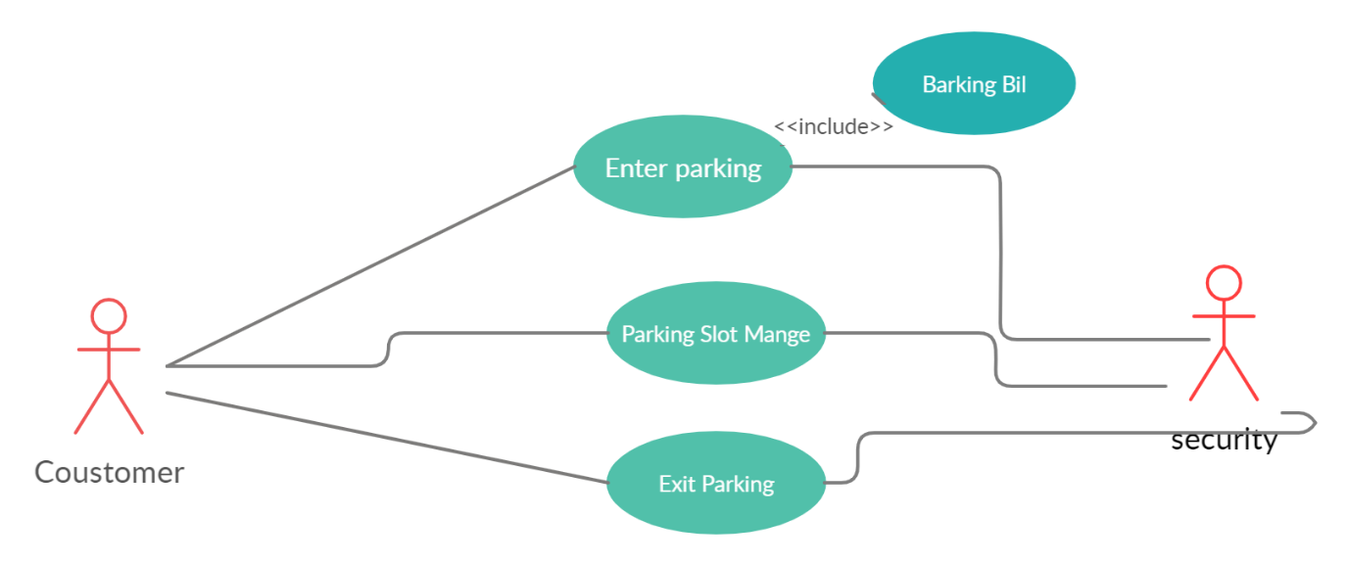

Figure 3

## **(2.4) Draw back of the current system**

In Sri Lanka there are lot of parking areas. But the problem is it is hard to make a space when we needed. In some situations, we must face some accidents due to the lack of proper management of the parking area. In a parking area there is a security person or someone to take care of them and guide the drivers into the parking area. But this is not 100% successful method, because still there can be theft or something illegal problem

Robberies are another issue. Thieves can steal vehicle parts and damage them. This is very common issue that we can see in every crowded area in Sri Lanka.0

Vehicle owner always require avoiding accidents which can damage their vehicle in a parking area. This is a common issue. But unfortunately, such situation can be occurred when we park our vehicle and when we try to come out of the park

In addition to this problem, there is another problem called functional problems. They include insurance premiums, heating, ventilation, electricity, and staff. It has been proven that insurance premiums can be reduced by 50 to 70 percent based on the reduction of incidents caused by driving and the virtual elimination of gaps. Heating is not required since there are no humans in the garage. Because no engines are running in the garage, emissions are reduced, and ventilation requires to only two air exchanges per hour. Electricity is reduced because there is no need for constant lighting and the fact that no elevators need to service the garage.

## **Summary**

We discussed all the current situation related to this existing parking system and weaknesses of them. We compared both manual and automated system, to discuss benefits of an automated system.

# **Chapter 3 - Requirement Specification**

## **(3.1) Functional requirements**

What is a Functional Requirement?

Functional requirement describes the functions a software must perform. It can be a calculation, data manipulation, business process, user interaction, or any other specific functionality which defines what function a system is likely to perform.

### **Algorithms**

We use Algorithms to protect our clients’ data, capture any formulas or manipulations of data elements (payments) that need to occur.

### **Database**

We use Database option to store client login details, vehicle details, parking spaces details, and some calculations. MySQL is chosen to be the DBMS of the system, due to flexibility.

### **Backup and recovery**

Backup and recovery help to manage and reuse the previous records if we want to add something new to system it easy to access and check the feasibility of the new option.

Also, it can be used in the security purposes (police inquiries)

### **Other functioning requirements**

* Sign-up and register page
* Logging in with Google and its verification
* Phone number verification
* An “I forgot my password” section that sends a link to the verified email
* Completing, editing, adding, and deleting different fields in the resume (developer)
* Applicant’s dashboard page
* A feature to Filter and organize as the customer requirements

## **(3.2) Non-functional requirements**

### **Performance and scalability**

How much will this performance change with higher workloads? Explains how fast does the system return results?

We have used the technologies which are compatible with each other, we are assuming there will be a lots of users use this system at the same moment, so we are responsible to make a system which can afford huge workload without crashing.

### **Portability and compatibility**

Which hardware, operative systems, browsers, and their versions will the software system run on? Will it conflict with different applications and processes at intervals these environments?

When we creating the desktop application we found that most of the people are familiar with windows OS, but we build a system that can be easily used by most of the people without noticing the system which we used.

In the mobile application development in first phase we choose ANDROID which is most used, and we are planning to expand it to IOS platform. We want to use this system by lots of people, so we create the mobile application to compatible with android older versions too.

### **Reliability, availability, maintainability.**

How usually will the system expertise important failures? And the way a lot of time is it accessible to users against downtimes?

We are planning to prevent main system failures. We also consider about the integrity of the system. So, we maintain our system frequently, users can keep Reliability on us. We are planning to prevent main system failures. We also consider about the integrity of the system. So, we maintain our system frequently, therefore users can keep Reliability on us.

### **Security**

How are the system and its data protected against attacks?

We use an algorithm to protect the data which are stored in the database, and we also don't misuse the data.

### **Usability**

How easy is it for a customer to use the system?

We use easy UIs for mobile and desktop applications, it will be helpful to all users to find a parking space, pay the parking fee. Desktop application also same as the mobile application, therefore users do not confuse when using the parking.

We use C# to give comfortable user.

## **(3.3) Performance requirements**

### **Response Time**

Our goal is making customer satisfaction, therefore we trying to reduce the response time in every step. When we check the system before language, we are checking the response time.

It should be below 0.1 seconds and do not exceed 5 seconds.

### **Workload**

We mentioned above we assumed there will be a lot of users use this system at the same moment, so we are responsible to make a system to compatible with it.

The technologies which we are used to implement this system will help to do as per our expectation (Python, JAVA, C#, MySQL)

### **Platform**

Mainly we develop the android app as the mobile app, and we are planning to expand to IOS platform.

We develop desktop application using JAVA, it is easier to developer and to the user (security guard)

## **(3.4) Security requirements**

### **Access, Authentication, and Authorization Management**

We have responsible to protect our users' details and privacy, So We are authenticating the user who are trying to log. Then also tracking the admins' behaviours

### **Other Security requirements**

Disaster Recovery Planning and Data Backup for Information Systems and Services

Electronic Data Disposal and Media Sanitization

## **(5.5) Hardware requirements**

When we are selecting hardware requirements, we should consider about the budget of the client who invest to this.

As a business purpose we trying to select the best but low-cost equipment.

We are using the hardware components which are compatible with our developing system.

We use these hardware components below mentioned

* LPR camera,
* Ultrasonic sensor
* Two Monitors
* 360 cameras, • Automatic gate barrier, Alarm

# **Chapter 4 - Feasibility Study**

## **(4.1) Technical Feasibility**

* The proposed system will be developed in web bases completely and it is requiring using mobile application and desktop base technologies appropriately.
* Technology to build the overall system is available. Currently available mobile and desktop technologies-JAVA, Flutter, Swift, C#, JAVA SP, Visual basic.
* Servers: Microsoft IIS, Apache, Google web server, Apache Tomcat
* DBMS: Oracle, MySQL, Microsoft SQL server, Microsoft Access
* Our system is developed using JAVA, C# as the main development language due to client’s hardware specification. MySQL is chosen to be the DBMS of the system, due to flexibility. We can develop this application because of this java platform independent. It is easy to manage developer. C# gives a comfortable user experience and give user interface.
* Available image processing language- C++, Python, Jupiter notebook.
* Python is easier to handle than C++ to developer. Python has many libraries. They can implement (open cv, NUMPY, Skippet....)
* Source Availability: Desi Open Source Software Sources Available Vitaly and Knowledge is available for free through the Internet.
* Expert technical expertise: The software team does not currently have the necessary expertise to complete the system, but Tim can specialize in technologies within a given period.

## **(4.2) Operational Feasibility**

* Potential users of the system are familiar with the website navigation and handling. Hence training up to necessary level would be easy.
* Existing internal network - The implementation of the system in the intranet can be easily managed, and the security issues needs to be addressed in network level or else in the application level.
* C# and Java support object-oriented development approaches so that well defined design can maintain the smooth run and the flexibility of the proposed system.
* Security issues - User access levels will be set, and the system will only allow privileged users. Authentication, Authorization and Audit procedures will be facilitated to the system administrators.
* Data retrieval and the data presenting will be done by the system so the report generation will be automated by the system

## **(4.3) Economic Feasibility**

Benefits - above task

* Better efficiency and effectiveness in the maintenance of personal information details and calculations in the leave system thus reducing human errors.
* Saving on time and paper cost of manually entering data and generating reports thus improving communications.
* Better user motivation and flexibility due to improved efficiency in dealing with user friendly interfaces etc.
* Parking slots is not wasting because it’s working 24/7.
* Reduction in labor cost as fewer employees would be needed in entering the data into the system and processing the information.
* Personal information and would be easily managed by the database thus saving the storage space on file cabinets and maintenance
* Data redundancy and security issues would be lessened due to improved backup and security features in the system.

## **(4.4) Organizational feasibility**

* We get information and updates about the new parking spaces from the urban development authority and also government and private sector organizations can apply this system.

## **(4.5) Outline budget**

We can divide the cost into the few categories.

* Development and Purchasing Costs.
  + - * Hardware- LPR camera, Ultrasonic sensor, Two Monitors, 360 camera, Automatic gate barrier, Alarm
      * Software – 1. Operating System (Already installed and no need to change 2. Main software needs to build the system (Open source software - Free 3. Cloud storage 4. Other software (Total cost*25%)
* Installation and Data entry Costs -
  + - * + Install the system.
        + Enter previous data into system.

### **Budget**

|  |  |
| --- | --- |
| **Name** | **Price** |
| 1. Cloud Storage | $300 |
| 1. Images | $30 |
| 1. LPR (Camera) | $168 |
| 1. Hikvision 2MP 8Ch DVR Camera | $500 |
| 5. Automatic gate barrier | $350 |
| 6. other (CPU, Monitor, Sensor) | $400 |

## **Summary**

Feasibly report identified manly technical operational ,economic organizational and our beget technical feasibility show what programming language and what is best way of the software and hard ware development mythology .operational fusibility is identified the user operational best ways and it has user problem and how to manger it. economic fusibility is defending the how to market and how many budgets will be going this project example (how to marketing this application an how many and how to it...)

# **Chapter 5 - System architecture**

## **(5.1) ER diagram and Use case /system module**

Figure 4

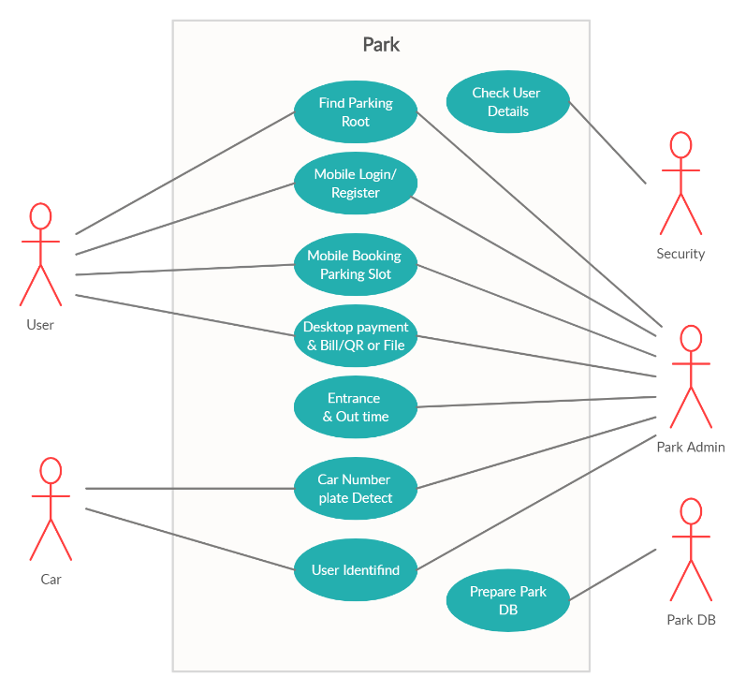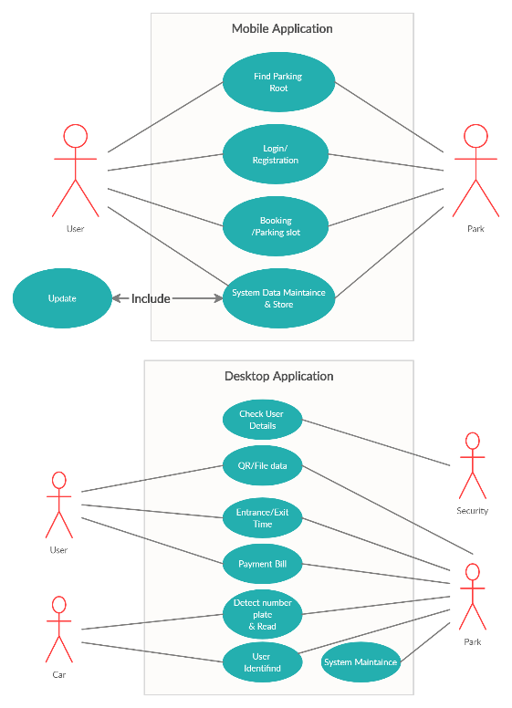

Figure 5

Figure 6

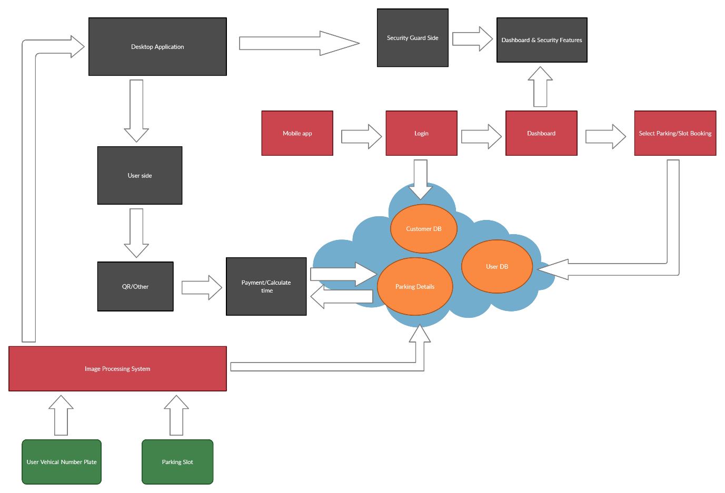

Figure 7

Figure 8

## **(5.2) High-level architecture diagram**

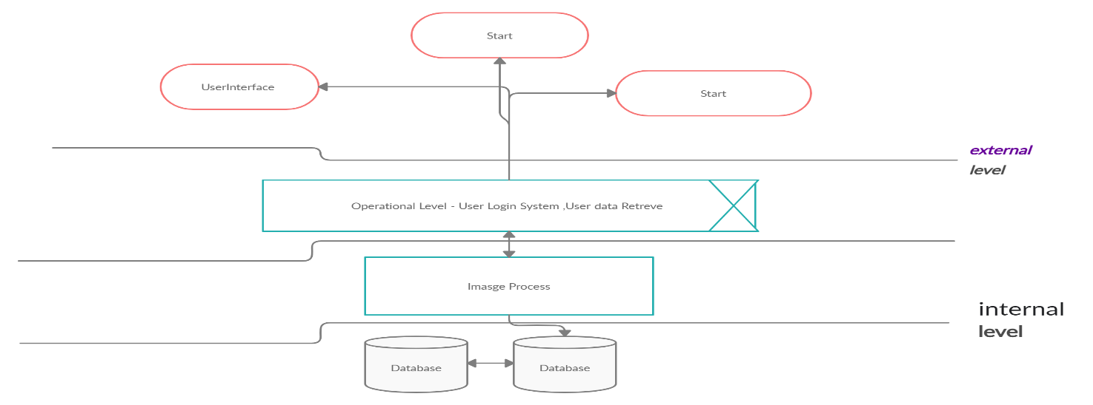

Figure 9

## **(5.3) Class diagram of the proposed system**

## 

# **Chapter 6 - Development tools and technology**

## **(6.1) Development methodology**

Primarily this System has two software and one hardware prat. this here mainly use SDLC *(*parallel development) and Rapid Application Development methodology .in addition we use DevOps deployment methodology.

**How to use parallel Development in this system/** **Rapid Application Development methodology**

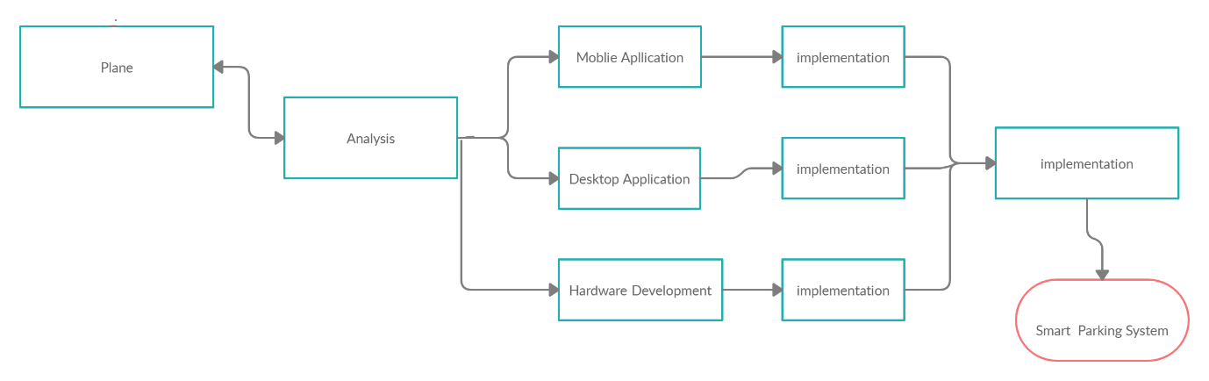

Figure 10

(1.7)

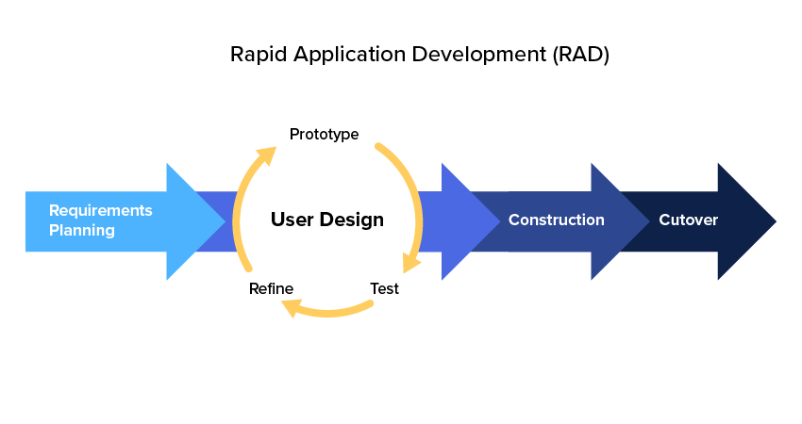This use all subprojects are complete, there is a final integration of the separate pieces, and the system is delivered. This system has three sub projects. parallel system has five steps. In order they are plane analyse, development, implementation system. Now let us look at one of the part plane is a using create a proposal and confirm the opinion for expect system. After confirming We will be going analysis (second stage) they use crate feasibly study, technical report and system analysing reports. this part term member is overall participation this stage. next stage is a development stage. development stage has mainly tree part. they are mobile application desktop application and hardware development. and after implement al part .it is a final stage

Figure 11

**Rapid Application Development Advantages**

* Flexible and adaptable to changes
* Due to the prototype in nature, it is less likely to cause defects
* Each stage in RAD gives the customer a higher priority function

## **(6.2) Programming languages and tools**

* Programming languages – C# (dot net framework), python, java
* Tool – firebase, Google API, azure/google cloud, Arduino

Mainly mobile application develops by java with android studio. manly azure DB use parking slot mange and app logging page design by firebase authorization. firebase is a free service and easy to implement android studio. Google API use to imputes system map .it is got Google API services.

C# is used to desktop application mainly doctor application is two part .I think this c # dot net formwork is easy to develop and it can be give user best UI/UX mainly we target windows system and C# is easy to connect with azure DB and reserve security side

Python is used to image processing system mainly we read number plane and parking space They ident find the above tow comports. manly we use open cv.

Mainly gate system design by Arduino. manly this part has gate system control.

## **(6.4) Algorithms**

* OpenCV: Automatic License/Number Plate Recognition (ANPR) with Python
* Data encryption standard symmetric-key algorithm.

Open cv algorithm is used to identified number plate and user face recognition. It is develop by python .data encryption is use good user security and data protection step.

## **(6.5) Hardware tools**

Mainly we will use audio bord , parking barrier, two camera .camera is a identified the vehicle number ,vehicle speed and parking slot all camera connect by Wi-Fi or network cable (rg445) and parking barrier is connect Arduino bord and motor out value represent parking barrier up and down .

## **Summary**

parallel Development mythology is use develop this project (system) it is mainly 4 stage. This mythology 3 rd. stage is specially it is derived the project part and after implement project part. RAD is used mobile application and Desktop with above mythology.it benefit is a prototype using and get normal view this structed. this system has two algorithms they are represent user security and easy to manage image processing system.

## Discussion

Discuss and identified general problems of current parking system and expecting system. how to get parking datils and parking organization details. Discuss project budget and project revetments. study a new technology’s can be implement expecting project

# References

Retrieved from https://www.youtube.com/watch?v=dLLEP9Xlcas

Retrieved from https://www.youtube.com/watch?v=4Wv3YNjchts

Retrieved from https://ieeexplore.ieee.org/document/5941663

# 

# **Team plan and responsibilities**

|  |  |  |  |  |  |
| --- | --- | --- | --- | --- | --- |
| Member | Plymouth index no | Name | Tasks carried out | Future plan | Comments by the group leader |
| 1 | 10707373 | S.K.Y Silva | Chapter 6 - Development tools and technology | Find new tech and improve this project. | Lead by member’s,  Find information and try chapter 6 |
| 2 | 10707128 | R.G.K.D Amarasooriya | Chapter 2 - System Analysis | Find new tech and improve this project. | Chapter 2 all information Resch and analyze information, good contribution |
| 3 | 10707391 | H.W.N Thathsara | Chapter 1 - Introduction | Find new tech and improve this project. | Introduction is complete , good contribution |
| 4 | 10707165 | P.N De Silva | Chapter 4 - Feasibility Study | Find new tech and improve this project. | Feasibility study and find a budget cost , good contribution |
| 5 | 10707095 | G.M.S Lakshan | Chapter 3 - Requirement Specification | Find new tech and improve this project. | Our system problems gather and collect of requirement, good contribution |
| 6 | 10707295 | R.D Paranawithana | Chapter 5 - System architecture | Find new tech and improve this project. | All diagrams are create by resmitha. ,  good contribution |